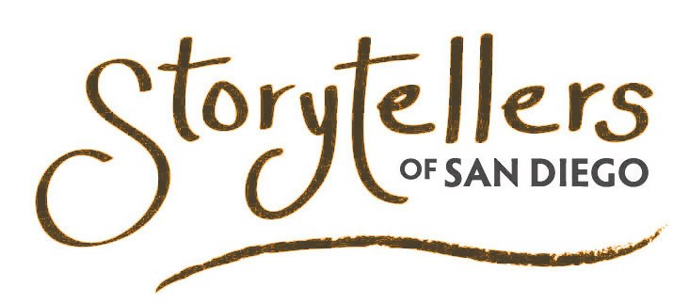
Don’t Miss a Word

13142 Sundance Ave
San Diego, CA 92129

Phone: (858) 484-1325
www.storytellersofsandiego.org

Board of Directors
Jim Dieckmann
Chairman
jdieckma@gmail.com

Marilyn McPhie
Li-Anne Rowswell Mufson
Patti Christensen
Dave Watters
Sheila Thompson
OJ Mozon Jr.
Deidra Davis

Officers
Marilyn McPhie
President
mmcphie@gmail.com

Patti Christensen
Vice-President

Jim Dieckmann
Treasurer

Li-Anne Rowswell
Mufson, Secretary

Storytellers of San Diego is a 501(c)3 nonprofit, public benefit corporation dedicated to promoting storytelling as an art form in San Diego County EIN 45-5050462

